Is Kettering a Diverse Community?

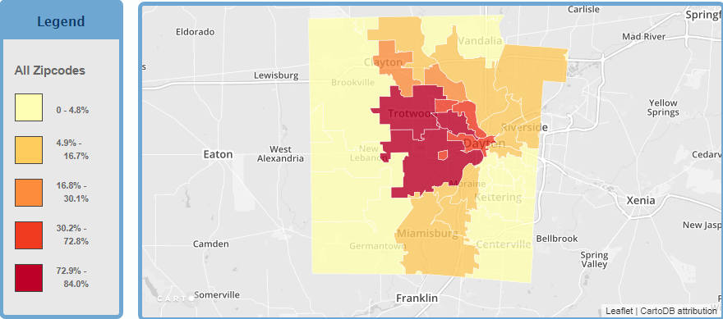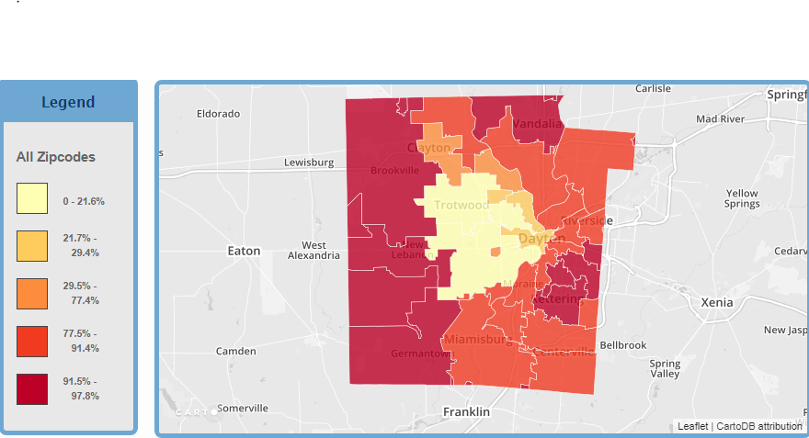
Black Population Table White Population Table

Sources
- "Population: Percent of population by race, White, 2010",,
Data Source: US Census, 2010,,
- "Population: Percent of population by ethnicity, Hispanic, 2010",,
Data Source: US Census, 2010,,
- Population: Percent of population by race, Black, 2010",,
Data Source: US Census Bureau, 2010,,
- "Population: Percent of population by race, Asian, 2010",,
Data Source: U.S. Census, 2010,,
- Population: Percent of population by race, American Indian/Alaska Native, 2010",, Data Source: U.S. Census, 2010,,
- http://ephtp.phdmc.org/page/display_section/population_demographics

According to the graph Montgomery County is not a diverse community. The graph shows each population and how many there are at each zip code. As seen in the graph white race is the largest out of all the others it has a range from about 62 – 98, with a few low outliers. The black race is second largest with a range from about 0 – 35, with a few high outliers. So as you see tell Montgomery County isn’t a diverse area, its mainly white and black ethnicities, with almost double in white ethnicities.

